Augmenting the South East Flows Restoration Project

Hydrological Modelling – Stage 1 review

# Introduction

The South East Flows Restoration project (SEFRP) is an investment made by the Government of South Australia and the Australian Government to assist salinity management in the Coorong South Lagoon, to enhance flows to wetlands in the Upper South East and to reduce drainage outflow near Kingston SE. The SEFRP proposes a new channel connecting existing elements of the South East Drainage Network to divert water northwards from Blackford Drain into the Taratap and Tilley Swamp systems, connecting to the Morella Basin to flow into the Coorong South Lagoon at the Salt Creek outlet. The SEFRP will provide capacity to deliver a median volume of up to 26.5 GL/a directly into the Coorong South Lagoon, with capacity to deliver water to local wetlands concurrently.

The SEFRP will construct a channel from the Blackford Drain to the southern end of the Taratap Drain (approximately 13 kilometres) and will widen the existing Taratap and Tilley Swamp Drains (approximately 81 kilometres) to capacity of 600 ML/d. As water approaches Tilley Swamp, the Tilley Swamp Watercourse will preferentially be used to convey water to the Coorong and the Tilley Swamp Drain used in years where faster water transfer is required. Construction works are scheduled to commence in early 2017 and scheduled for completion in mid-2018.

In 2012, South Australia developed the South East Solution (SES) proposal, which included options to divert additional water from south of the Blackford Drain, including a new channel along the Reedy Creek Flats or an extension of the Blackford Drain through to the Avenue Flat drains. Both of these options were designed to access surplus water from Drain L, Drain K and potentially Drain M, which is currently discharged into the ocean. The SES proposal was assessed to provide an additional 13.5 – 25.5 GL to the Coorong, depending on which sub catchments were included. Due to stakeholder concerns, funding constraints and the need for further community consultation, the SES elements did not part of the final SEFRP scope.

Future augmentation of the SEFRP, through the diversion of additional water from the Drain K catchment (including Drain K, Avenue Flat K Drain, and Wilmot Drain), to the south of Blackford Drain, will allow greater volume, security and delivery flexibility, thereby improving the maintenance of Coorong South Lagoon salinity within target range.

This report presents the assessment of potential yield to the Coorong from an augmented SEFRP that follows the Blackford Extension alignment. Previous analyses of diversions from the Drains L catchment into the Blackford Drain for SEFRP augmentation (e.g. AWE, 2012, Taylor *et al.*, 2014), together with the associated hydrological models, have been re-evaluated to analyse potential yields up to December 2016. The Drains L&K catchment (including Drain K, Wilmot Drain and Bray Drain) is one of the most reliable westerly-flowing drainage networks in the South East region.

# Objective

The objective of this investigation was to assess the increase in catchment yield (less transmission losses) that could result from augmenting the SEFRP to include diversions from the Wilmot and K Drains catchment. This assessment was to be undertaken over the long-term period of assessment used in Murray-Darling Basin Planning (i.e. commencing in 1895 up to at least 2009).

# Modelling Drain K catchment yields

## Rainfall-runoff model

As part of a 2014 investigation by DEWNR (Taylor *et al.*, 2014), a model of Drains L&K was developed in the eWater Source IMS framework. This model, as shown in Figure 1, was used to assess yields from the wider catchment, as input to Lake Hawdon. Two supply points were included in the catchment model, representing potential diversions from Wilmot Drain (in the south), and Drain K towards Blackford Drain, along the Blackford Extension alignment as described in AWE (2012).

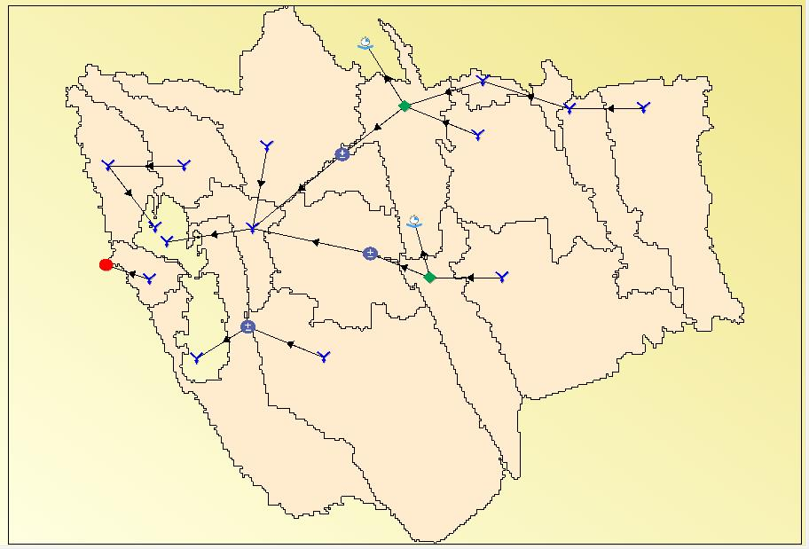The Drains L&K model was simulated over an 1889-2016 period, using rainfall-runoff parameters that were calibrated in 2014. No demand constraints were applied at the supply points, and daily flows downstream of the two supply points were analysed to investigate the impact of maximum diversion rates from the two watercourses for an augmented SEFRP.

Figure eWater Source model geographic layout for the Drains L&K system

## Model Diversions from the Drain K Catchment

An augmented SEFRP will include connections between Wilmot Drain and Drain K (utilising a combination of new channels and existing drains including Avenue Flat Drain), and between Drain K and Blackford Drain (new channel). A range of potential maximum rates for diversion from the Drain K and Wilmot Drain diversion points were assessed to determine the relationship between maximum diversion rate (hence the flow capacity of new channel works) and annual yield to the Blackford.

Maximum diversion rates of between 50 ML/d and 250 ML/d from Wilmot Drain (into Drain K) were analysed, with maximum rates out of Drain K (which include the contribution from Wilmot Drain) analysed up to a daily flow capacity of 500 ML/d.

Figure 2 summarises the relationship between peak daily flow and average annual yield from diversions from both Drain K and Wilmot Drain. The various lines shown in Figure 2 represent different scenarios that consider a range of maximum diversion rates from Wilmot, ranging from 0 ML/d from Wilmot (i.e. all flow to Blackford being diverted from Drain K only), up to a maximum of 250 ML/d coming from Wilmot.

These results suggest a significant increase in yield obtained from connecting Wilmot Drain into the Drain K diversions to Blackford.

Figure Relationship between peak daily flow and average annual yield to Blackford from Drain K and Wilmot Drain (1889-2016)

Figure 3 shows the relationship between peak daily diversion and median annual yield to Blackford Drain (for the various scenarios of Wilmot Drain diversion capacities), with Figure 4 showing the relationship between peak daily flow and an estimate of 80th percentile annual flows (chosen to represent wet years in this system).

Figure Relationship between peak daily flow and median annual yield to Blackford from Drain K and Wilmot Drain (1889-2016)

Figure Relationship between peak daily flow and annual yields to Blackford from Drain K and Wilmot Drain (1889-2016) having 20% exceedance

Table 1 summarises the characteristics of flows from Drain K into Blackford Drain across the 128 year simulation period (1889-2016), assuming a maximum daily diversion rate of 300 ML/d with different contributions from Wilmot Drain to these diversions. These results show that greater volumes, and flexibility of supplying flows to Blackford, can be obtained by increasing the potential contribution from Wilmot Drain. These different scenarios were analysed in an approach that can be described by way of example that considers a peak contribution of 200 ML/d from Wilmot Drain combined with the peak diversion of 300 ML/d to Blackford Drain (as shown in the far right column of Table 1). On a given day that there was only 100 ML/d available in Wilmot; it could be possible in this case to divert up to 200 ML/d from Drain K (if available), with this not being limited to the difference of 100 ML/d, and still having a full 300 ML/d diverted to the Blackford.

Table Summary of annual yields (1889-2016) from Drain K and Wilmot Drain to Blackford Drain at a maximum diversion rate of 300 ML/d, with different contributions from Wilmot Drain

|  |  |  |  |  |  |
| --- | --- | --- | --- | --- | --- |
|  | Drain K only | Drain K + 50 ML/d max from Wilmot | Drain K + 100 ML/d max from Wilmot | Drain K + 150 ML/d max from Wilmot | Drain K + 200 ML/d max from Wilmot |
| Average (ML/a) | 9,934 | 15,546 | 17,222 | 17,859 | 18,026 |
| Median (ML/a) | 7,583 | 13,604 | 15,133 | 15,881 | 16,024 |
| 80th percentile (ML/a) | 17,291 | 24,466 | 26,944 | 27,634 | 27,757 |

Figure 5 shows the time series of annual yields to the Blackford (1889-2016) for the case of a peak total diversion of 300 ML/d from Drain K. The additional yield that results from increasing the contributions from Wilmot Drain are shown.

The time series of daily flows entering the Blackford from the Drain K catchment for the 128-year simulation period, under a range of scenarios that consider various peak flows with different contributions from Wilmot Drain, were then analysed alongside yields from the Blackford catchment to determine potential flows into the SEFRP infrastructure.

Figure Time series of annual yield to Blackford Drain at 300 ML/d peak diversion from Drain, showing different peak contributions from Wilmot Drain

# Modelling SEFRP yields

## Rainfall-runoff models

Flows generated from the Blackford Drain catchment were simulated using a WaterCress model originally developed in 2010 as part of a flow strategy for the South East of South Australia (Wood & Way, 2011). The Blackford-Fairview WaterCress model schematic is provided in Figure 6.

The proposed connection of the Drain K catchment into the Blackford Drain catchment is modelled by the flow path from the *BF8* catchment through to the *BF7* catchment. Nodes *BF1* and *BF2* represent runoff from subcatchments to the west of the augmented SEFRP flow path, including the Jackie White Drain. SEFRP diversions from the Blackford Drain occur from the *BF-rs4* routing node, and flows leaving this node were analysed to determine volumes of water available for diversion. The catchment nodes *BF5* and *BF9* represent subcatchments of the Blackford Drain downstream of the diversion point that will become additional local catchments supplying flows for the SEFRP.

The linkage between catchment nodes *FVW05* and *FVW07* represent the supply of water from the Fairview Drain catchment into the Blackford catchment achieved through the opening of a regulator at the Keilira Rd monitoring gauge (A2390569). When this regulator is closed, flow in the Fairview Drain “backs up” and can then be supplied in the Bakers Range watercourse to flow northwards. Catchment node *FVW07* represents the subcatchment of the Fairview Drain (3977 ha) downstream of the regulator.

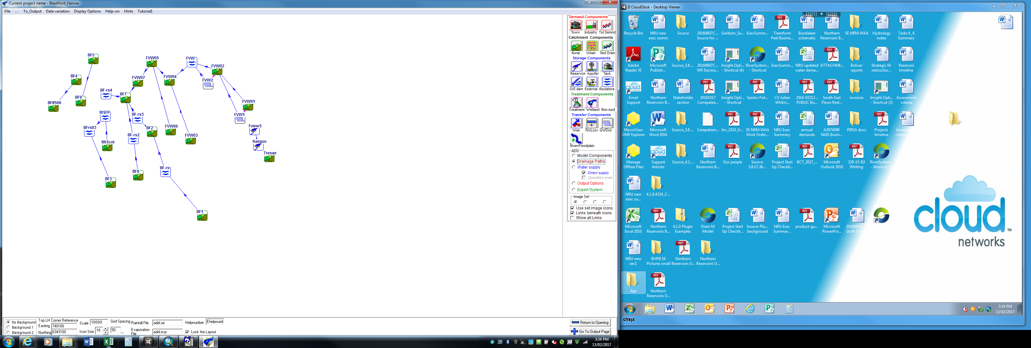Figure WaterCress model schematic for Tresant, Fairview and Blackford systems

The Blackford-Fairview WaterCress model was simulated both with and without the contribution of the Fairview Drain to flows in the Blackford to assess different possible operational scenarios. The drainage connection between *FVW05* and *FVW07* was removed to enable Blackford catchment flows to be simulated without the contribution of the Fairview.

Flows generated from the Taratap Drain and Tilley Swamp catchments (which will form the flow path for the SEFRP), and contributing systems including the Kercoonda, West Avenue/Wimpinmerit, and Northern Outlet systems were modelled through a WaterCress model (the *WAWC_TS_TTP_NO* model) originally developed in 2010 (Wood & Way, 2011), as shown in Figure 7.

Runoff from the Didicoolum Drain catchment and Ballater East Drain catchment are modelled as the *Didi* and *Ball* nodes. The West Avenue watercourse and Wimpinmerit Drain system contribute flows to the Taratap Drain via Henry’s Creek, and modelled as flows leaving the *HCk* node.

Runoff from the local catchments of the Taratap Drain system were modelled as the sum of yield from the *Tar1*-*Tar6* nodes, with runoff to the Tilley Swamp watercourse modelled as the sum of the *TS1*-*TS5* catchment nodes. Local runoff to the Morella Basin was modelled as the yield from the *More* node.

Climatic input files for the WaterCress models shown in Figure 6 and Figure 7 were extended to end 2016 to enable 128-year simulations of these two models (representing 1889-2016). No changes were made to parameters of these previously calibrated rainfall-runoff models.

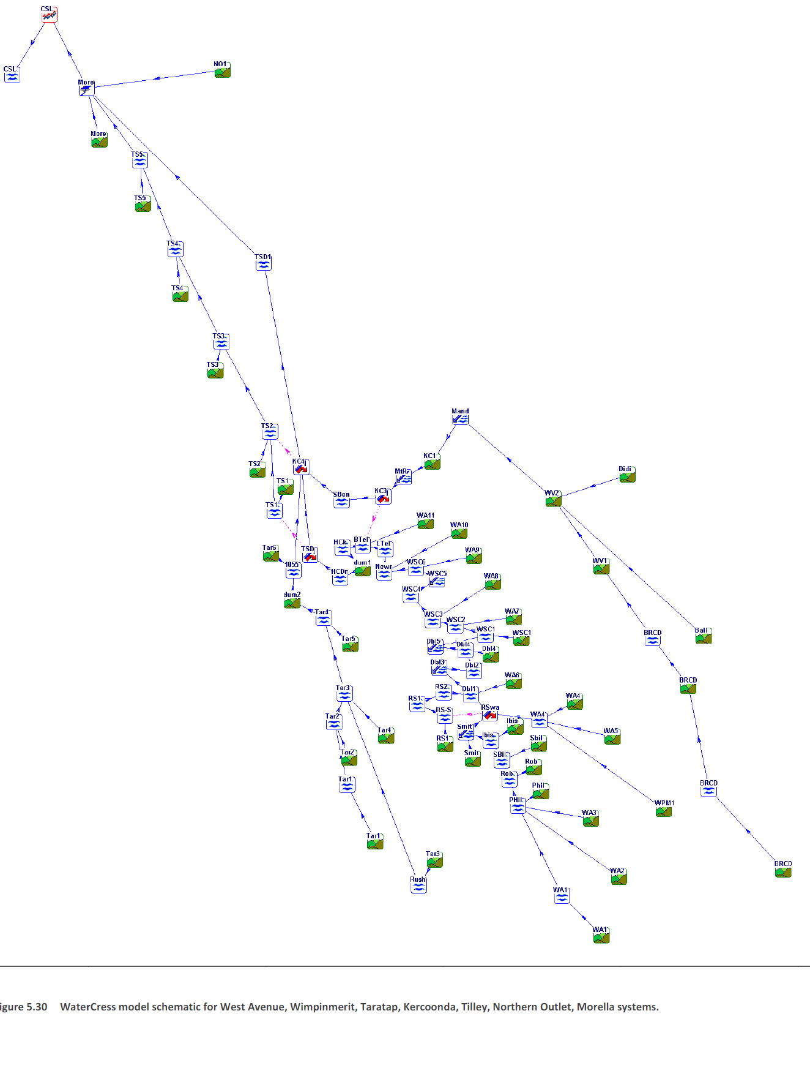Figure WaterCress mode schematic for West Avenue watercourse, Tilley Swamp, Taratap, Keerconda Drain, Northern Outlet and Morella systems (WAWC_TS_TTP_NO model)

## Modelling transmission losses

Transmission losses from flows through the Taratap Drain and Tilley Swamp systems were modelled with a MS Excel-based water balance model originally developed in 2011 by DEWNR (Montazeri *et al.,* 2011) and further developed by AWE (AWE, 2012 and AWE, 2015) to inform potential SEFRP yields for this Blackford Extension. This spreadsheet model contains relationships between flow depth and surface area, and hydraulic conductivity (k) for the various SEFRP reaches. Daily rainfall and evaporation for 1889-2016 were used as inputs to the water balance model to determine net evaporation losses along the whole SEFRP flow path.

Although the SEFRP will ultimately connect the Blackford system to the Taratap Drain system, there was no attempt made to update the WaterCress models to include flows from the Blackford system together with the systems to the north of the Blackford diversion point. The two models were run separately, with time series of daily flows taken as input to the water balance model.

The complete list of input time series for the water balance modelling included:

* Total diversions from Drain K, Avenue Flat and Wilmot Drain, as calculated from the eWater Source model
* Total yield from the Blackford catchment that is available for diversion (with and without the addition of flows from Fairview Drain), as calculated in the Blackford-Fairview WaterCress model as flow leaving the *BF-rs4* node
* Runoff from the Blackford Drain catchments downstream of the diversion point, as calculated in the Blackford-Fairview WaterCress model as flow leaving the *BF5* and *BF9* nodes
* Runoff from the Taratap Drain local catchments, as calculated in the WAWC_TS_TTP_NO WaterCress model as flow leaving the *Tar1*-*Tar6* nodes
* Runoff from the Tilley Swamp local catchments, as calculated in the WAWC_TS_TTP_NO WaterCress model as flow leaving the *TS1*-*TS5* nodes
* Runoff from the Morella Basin local catchment, as calculated in the WAWC_TS_TTP_NO WaterCress model as flow leaving the *More* node
* Total yield from the Kercoonda system passing the S-bend regulator, as calculated in the WAWC_TS_TTP_NO WaterCress model as flow leaving the *SBen* node
* Total yield from the West Avenue watercourse passing Henry’s Creek, as calculated in the WAWC_TS_TTP_NO WaterCress model as flow leaving the *HCk* node
* Daily rainfall and pan evaporation for 1889-2016 for specific areas as provided by the SILO patched point dataset

## Model Evaluation

The resulting annual volumes to the Coorong from the rainfall-runoff (WaterCress models), used as inputs to the transmission loss spreadsheet model calculated for the existing drainage network have been compared to recorded volumes since the record started in 2001.

It can be seen from Figure 8 that the modelled annual volumes are greater than the observed volumes (A2390568) in the period up to 2009. This is the expected result, as the model includes existing drains consistently throughout the modelled period, where in reality there was drain construction through the Upper South East Program from 2003-2008, as well as the Bald Hills Drain in 2011/12. It can be seen that from 2011 onwards, when the drains in the model reflect what was constructed on the ground, the 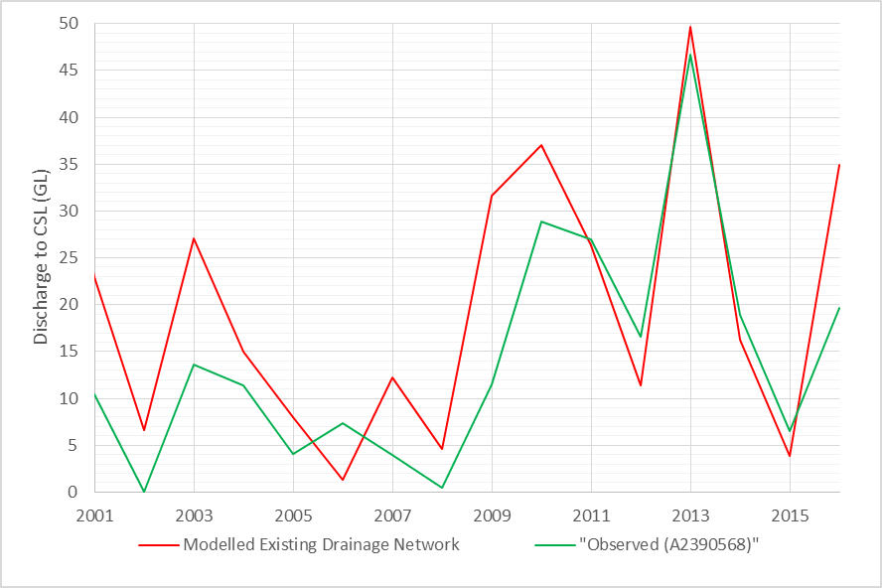modelling provides an accurate representation of the recorded flows to the Coorong.

Figure Modelled and observed flow to the Coorong at Salt Creek. It should be noted that in the early part of the record the model includes drains that have not yet been constructed, and as such is expected to have more discharge than observed.

# Potential yields to the Coorong – historical climate

The yields from the augmented SEFRP, utilising the Blackford Extension, were assessed across a range of modelling scenarios. Scenarios 1-7 analysed varying rates of diversion from Wilmot Drain and Drain K, alongside a maximum diversion rate of 600 ML/d from Blackford Drain to the Taratap system. Scenario 8 considered the contribution of Drain K only – assuming that the SEFRP is augmented only to include Drain K, but not augmented to include the contribution form Wilmot Drain. Scenario 9 considered no augmentation to Drain K, thereby representing the current extent of the SEFRP. Scenario 10 considered only the existing drainage network, with no SEFRP development – hence no diversions from Blackford into Taratap Drain – and was analysed to demonstrate the increases in yield for each scenario. Additionally, in each of these Scenarios 1-10, it was assumed that there was no connection between Fairview and Blackford Drains.

Table 2 summarises the average annual yields for various components of the augmented SEFRP from the 128-year simulation period for these 10 scenarios.

These simulations were then repeated using the assumptions of a full contribution of flows from Fairview Drain into Blackford Drain (Scenarios 1a-9a), i.e. no water diverted from the Fairview to the Bakers Range watercourse. Table 3 summarises the average annual yields for various components of the augmented SEFRP from the 128-year simulation period for these 9 additional scenarios.

These nine modelling scenarios were chosen to represent a range of potential configurations of an augmented SEFRP, with associated impacts on the average release to the Coorong South Lagoon. These results show that reducing the drain capacity from Drain K to the Blackford from 500 ML/d to 350 ML/d had a minimal impact on the average annual yield to the Coorong South Lagoon (e.g. comparing scenarios 2 and 4). These results also suggest that an increase in maximum diversion from Wilmot above 150 ML/d does not translate to significant increases in average release to the Coorong South Lagoon (e.g. comparing Scenarios 3 and 4).

A comparison of Table 3 with Table 2 shows that the permanent connection of Fairview Drain to Blackford Drain (with no water being provided form Fairview to Bakers Range watercourse) provides an additional average yield to the Coorong South Lagoon of at least 7,000 ML/a. The Fairview Drain provides additional volumes of water to the Coorong when the capacities of contributions from Drain K and Wilmot reduce. Scenario 9, representing the current extent of the SEFRP (and no connection to Drain K), shows an average annual benefit to the Coorong of more than 8,300 ML/a. The current extent of the SEFRP (Scenario 9a) reveals an average annual benefit over and above the existing drainage network (Scenario 10) of approximately 26 GL/a across the 128-year simulation 1889-2016. Previous yield estimates have used a time period of 1971-2000, and hence there is a slight difference in this updated yield assessment from the longer period used.

Table Summary of average annual yields (1889-2016) at different locations of the augmented SEFRP under a range of system configurations, assuming no connection between the Fairview Drain and Blackford Drain

|  |  |  |  |  |  |  |  |  |  |
| --- | --- | --- | --- | --- | --- | --- | --- | --- | --- |
| Scenario | Maximum diversion from Blackford (ML/d) | Maximum diversion from Drain K (ML/d) | Maximum contribution from Wilmot (ML/d) | Yield from Drain K/ Wilmot to Blackford (ML) | Yield from Blackford Drain (ML) | Henry Creek input (ML) | S-bend input (ML) | Release to CSL (ML) | Increase in release to CSL above EDN (ML) |
| 1 | 600 | 500 | 250 | 20,122 | 33,478 | 5,434 | 20,441 | 64,005 | +34,620 |
| 2 | 600 | 500 | 150 | 19,346 | 33,190 | 63,664 | +34,279 |
| 3 | 600 | 350 | 200 | 18,454 | 33,277 | 63,775 | +34,390 |
| 4 | 600 | 350 | 150 | 18,174 | 33,097 | 63,561 | +34,176 |
| 5 | 600 | 300 | 150 | 17,499 | 32,883 | 63,328 | +33,943 |
| 6 | 600 | 250 | 150 | 16,586 | 32,413 | 62,894 | +33,509 |
| 7 | 600 | 200 | 100 | 15,123 | 31,359 | 61,671 | +32,286 |
| 8 | 600 | 350 | 0 | 10,027 | 25,610 | 55,845 | +26,460 |
| 9 | 600 | 0 | 0 | 0 | 17,095 | 46,970 | +17,585 |
| 10 | 0 | 0 | 0 | 0 | 0 | 29,385 | - |

Table Summary of average annual yields (1889-2016) at different locations of the augmented SEFRP under a range of system configurations, assuming full contribution of Fairview Drain to Blackford Drain (with increases in yield that result from the inclusion of flows from the Fairview Drain shown)

|  |  |  |  |  |  |  |  |  |  |
| --- | --- | --- | --- | --- | --- | --- | --- | --- | --- |
| Scenario | Maximum diversion from Blackford (ML/d) | Maximum diversion from Drain K (ML/d) | Maximum contribution from Wilmot (ML/d) | Yield from Drain K/ Wilmot to Blackford (ML) | Yield from Blackford Drain (ML) | Henry Creek input (ML) | S-bend input (ML) | Release to CSL (ML) | Increase in release to CSL above EDN (ML) |
| 1a | 600 | 500 | 250 | 20,122 | 40,981 (+7,504) | 5,434 | 20,441 | 71,285 (+7,280) | +41,900 |
| 2a | 600 | 500 | 150 | 19,346 | 40,778 (+7,588) | 71,040 (+7,376) | +41,655 |
| 3a | 600 | 350 | 200 | 18,454 | 40,884 (+7,607) | 71,171 (+7,396) | +41,786 |
| 4a | 600 | 350 | 150 | 18,174 | 40,744 (+7,647) | 71,002 (+7,442) | +41,617 |
| 5a | 600 | 300 | 150 | 17,499 | 40,632 (+7,749) | 70,879 (+7,551) | +41,494 |
| 6a | 600 | 250 | 150 | 16,586 | 40,308 (+7,895) | 70,529 (+7,635) | +41,144 |
| 7a | 600 | 200 | 100 | 15,123 | 39,429 (+8,070) | 69,565 (+7,894) | +40,180 |
| 8a | 600 | 350 | 0 | 10,027 | 33,605 (+7,995) | 63,617 (+7,773) | +34,232 |
| 9a | 600 | 0 | 0 | 0 | 25,639 (+8,544) | 55,301 (+8,331) | +25,916 |
| 10 | 0 | 0 | 0 | 0 | 0 | 29,385 | - |

The distribution of annual yields from the Drains L&K catchment, annual volumes diverted from the Blackford Drain, and annual volumes released to the Coorong South Lagoon, for the various modelling scenarios investigated, are shown in Figure 9 to Figure 13 respectively.

Figure Distribution of annual yields from Drain K (including Wilmot Drain) to Blackford Drain

Figure Distribution of annual diversions from Blackford Drain into Taratap Drain for Scenarios 1-9, assuming no contribution of Fairview Drain into Blackford Drain

Figure Distribution of annual diversions from Blackford Drain into Taratap Drain for Scenarios 1a-9a, assuming the full contribution of Fairview Drain flows into Blackford Drain

Figure Distribution of annual releases to Coorong South Lagoon for Scenarios 1-9, assuming no contribution of Fairview Drain into Blackford Drain, alongside Scenario 10 representing releases from the existing drainage network

Figure Distribution of annual releases to Coorong South Lagoon for Scenarios 1a-9a, assuming full contribution of Fairview Drain into Blackford Drain, alongside Scenario 10 representing releases from the existing drainage network

It is understood that there are constraints on the conveyance of flows in the Tilley Swamp reach, downstream of the junction with the S-Bend connector, where higher flows may spill out of the floodway, into the Tilley Swamp watercourse. It should also be noted that the current transmission loss spreadsheet does not account for travel times and attenuation (spreading out) of the hydrograph along the flow path. As there are some uncertainties about the maximum flow capacity of the floodway in this section, and the hydrological modelling of peak flows, no flow controls were incorporated in the transmission loss spreadsheet at this stage. These effects, along with improved representation of the Tilley Swamp watercourse, are planned to be included in the expansion of this spreadsheet model into a hydrological model built in the eWater Source platform. Figure 14 shows a distribution of daily flows in this section for the 128-year simulation, using an assumption of maximum diversions of 300 ML/d from Drain K and 150 ML/d from Wilmot. The additional yields resulting from the permanent connection of the Fairview and Blackford Drains are also shown.

Figure Flow duration curve showing distribution of daily flows (1889-2016) downstream of the junction between the SEFRP flow path and the S-Bend connector, under an assumption of maximum diversion of 300 ML/d from Drain K (including a maximum 150 ML/d from Wilmot)

# Potential yields to the Coorong – Climate change scenarios

The study also considered two climate scenarios to assess the potential reduction in yield from the SEFRP (hence impact on releases to the Coorong) due to future climate change. To consider possible changes in a future climate, the projections both a median and dry future climate at 2030, adopted by AWE (2009) and Montazeri *et al.* (2011), were used. After comparison to recent projections, based on the IPCC 5th Assessment Report and downscaled by Goyder Institute for Water Research (2015). These projections were considered to still be representative. Separate adjustments were applied for the wet and dry periods each year, with the wet period defined as the months of July to October inclusive and the remainder of the year defined as the dry period. The adjustments were applied to the 128-year daily rainfall series (SILO patched point dataset, as used in previous analyses) to develop 2030 climate change inputs to the various hydrologic models (in order to determine runoff) and the SEFRP water balance model to determine releases to the Coorong South Lagoon. Table 4 summarises the adjustments used to develop the 128-year climate change scenarios, and for comparison, the range in rainfall and temperature projections across the Global Circulation Models (GCMs) for the rainfall station at Avenue (Downer), 26078, in Figure 15.

Table Climate change adjustments (as per Montazeri et al., 2011)

|  |  |  |
| --- | --- | --- |
| 2030 climate scenario | Season | Rainfall adjustment (%) |
| Median | Dry period | 4.1 |
| Wet period (Jul-Oct) | 6.9 |
| Dry | Dry period | 10.4 |
| Wet period (Jul-Oct) | 13 |

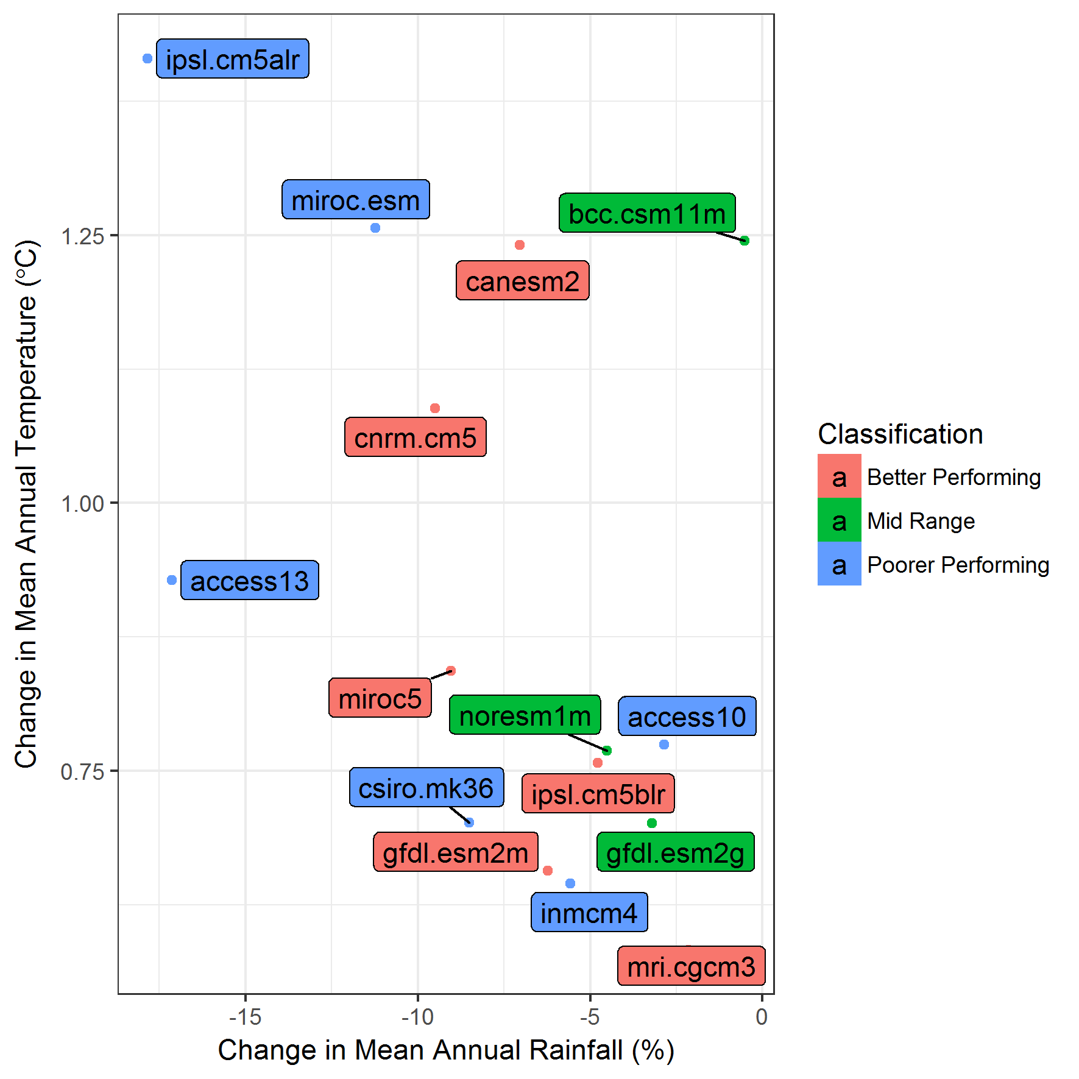

Figure Range in climate change projections for 2030 for the high emissions scenario (representative concentration pathway 8.5) (Goyder Institute for Water Research, 2015).

Table 5 summarises the potential yield from the augmented SEFRP, under various maximum diversions from Wilmot Drain and Drain K, for a 2030 median climate change scenario. These yields are shown as a comparison to yields under the historical climate case, as shown in Table 1. Table 6 shows the additional reduction in yield from the Drain K catchment that may occur under the 2030 dry climate scenario.

Table Summary of annual yields from Drain K and Wilmot Drain to Blackford Drain at a maximum diversion rate of 300 ML/d, with different contributions from Wilmot Drain for a 2030 median climate change-scenario

|  |  |  |  |  |  |
| --- | --- | --- | --- | --- | --- |
|  | Drain K only | Drain K + 50 ML/d max from Wilmot | Drain K + 100 ML/d max from Wilmot | Drain K + 150 ML/d max from Wilmot | Drain K + 200 ML/d max from Wilmot |
| Average (ML/a) | 7,442 | 12,323 | 13,716 | 14,228 | 14,365 |
| Median (ML/a) | 4,916 | 10,313 | 11,559 | 12,163 | 12,442 |
| 80th percentile (ML/a) | 12,515 | 19,195 | 21,516 | 22,395 | 22,615 |

Table Summary of annual yields from Drain K and Wilmot Drain to Blackford Drain at a maximum diversion rate of 300 ML/d, with different contributions from Wilmot Drain for a 2030 dry climate change-scenario

|  |  |  |  |  |  |
| --- | --- | --- | --- | --- | --- |
|  | Drain K only | Drain K + 50 ML/d max from Wilmot | Drain K + 100 ML/d max from Wilmot | Drain K + 150 ML/d max from Wilmot | Drain K + 200 ML/d max from Wilmot |
| Average (ML/a) | 5,149 | 9,170 | 10,239 | 10,619 | 10,719 |
| Median (ML/a) | 2,990 | 7,308 | 8,159 | 8,423 | 8,577 |
| 80th percentile (ML/a) | 8,220 | 14,511 | 16,935 | 17,827 | 17,932 |

Figure 16 and Figure 17 summarise the relationships between the peak daily flow and average annual yield from the Drain K catchment to Blackford under the two climate change scenarios, as comparison to the historic climate scenario shown in Figure 2.

Figure Relationship between peak daily flow and average annual yield to Blackford from Drain K and Wilmot Drain under a 2030 median climate change scenario

Figure Relationship between peak daily flow and average annual yield to Blackford from Drain K and Wilmot Drain under a 2030 dry climate change scenario

Table 7 summarises the average annual yields for various components of the augmented SEFRP from 128-year simulations under the two climate change scenarios, as calculated using the water balance spreadsheet as previously described. One configuration of the augmented SEFRP was considered for this analysis, including a maximum diversion capacity from Wilmot of 150 ML/d, 300 ML/d from Drain K into Blackford, and a maximum of 600 ML/d from Blackford Drain into Taratap Drain. The impact of additional yield from Fairview Drain into Blackford Drain was also considered by simulating the system with and without a connection between these systems.

These results show a reduction in the average annual release to the Coorong of approximately 15 GL/a under the Median climate change scenario, and 29 GL/a under the Dry climate change scenario.

Figure 18 to Figure 20 show the distribution of yields from Drain K, from Blackford and releases to the Coorong, from the 128-year simulations under historical climate, and under the two climate change scenarios.

Table Summary of average annual yields at different locations of the augmented SEFRP under historic and climate change conditions, assuming maximum diversion of 300 ML/d from Drain K, and 150 ML/d from Wilmot, with the impact of the Fairview Drain contribution shown

|  |  |  |  |  |  |  |  |
| --- | --- | --- | --- | --- | --- | --- | --- |
| Scenario | | Yield from Drain K/ Wilmot to Blackford (ML) | Yield from Blackford Drain (ML) | Henry Creek input (ML) | S-bend input (ML) | Release to CSL (ML) | Reduction in release to CSL from historical climate (ML) |
| 5 | Historic climate – no Fairview | 17,449 | 32,883 | 5,434 | 20,441 | 63,328 | - |
| 5a | Historic climate – Fairview included | 17,449 | 40,632 | 5,434 | 20,441 | 70,879 | - |
| 5_M | Median Climate Change – no Fairview | 13,881 | 26,405 | 3,235 | 16,473 | 48,779 | -14,550 |
| 5a_M | Median Climate Change – Fairview included | 13,881 | 33,520 | 3,235 | 16,473 | 55,660 | -15,219 |
| 5_D | Dry Climate Change – no Fairview | 10,310 | 19,928 | 1,590 | 12,526 | 35,132 | -28,196 |
| 5a_D | Dry Climate Change – Fairview included | 10,310 | 26,265 | 1,590 | 12,526 | 41,187 | -29,692 |

Figure Distribution of annual yield from Drain K catchment to Blackford Drain with maximum diversion 300 ML/d from Drain K (including 150 ML/d maximum from Wilmot Drain) under future climate change scenarios

Figure Distribution of annual yield from Blackford Drain to Taratap Drain with maximum diversion 600 ML/d, and 300 ML/d from Drain K (including 150 ML/d maximum from Wilmot Drain),under future climate change scenarios and showing the impact of contributions from Fairview Drain

Figure Distribution of annual releases to Coorong South Lagoon under future climate change scenarios and showing the impact of contributions from Fairview Drain

# References

AWE (2009). *Coorong South Lagoon restoration project—hydrological investigation final report June 2009*, prepared for Department of Water, Land and Biodiversity Conservation, Adelaide

AWE (2012). *South East Flows Restoration Project, Blackford Extension Alignment – Yield Analysis*, prepared for Department of Environment, Water and Natural Resources

AWE (2015). *South East Flows Detailed Design Hydrology – Yield Assessment*, prepared for Department of Environment, Water and Natural Resources

Goyder Institute for Water Research, 2015, SA Climate Ready data for South Australia - A User Guide, Goyder Institute for Water Research Occasional Paper No. 15/1, Adelaide, South Australia

Montazeri, M., Way, D., Gibbs, M., Bloss, C. & Wood, C. (2011). *Coorong South Lagoon Flow Restoration Project – Hydrological modelling and transmission loss analysis*, DFW Technical Note 2011/05, Government of South Australia, through Department for Water, Adelaide

Taylor, B., Gibbs, M., Hipsey, M., Lewis, M., Sharath, I., Brookes, J., Nicol, J., Clarke, K., Dalby, P., Clark, M. and Bice, C. (2014*). Investigations to inform diversion rules for the South East Flows Restoration Project in the Drain L catchment*, Government of South Australia, through Department of Environment, Water and Natural Resources, Adelaide.

Wood, G. and Way, D. (2011). *Development of the Technical Basis for a Regional Flow Management Strategy for the South East of South Australia*, DFW Report 2011/21, Government of South Australia, through Department of Environment, Water and Natural Resources, Adelaide.